# Michael Chillemi

# 07/12/2023

# CS 590 - Algorithms

# M8.B1: Module 8 The Greedy Method Reinforcement Exercises

Problem 10.5.6

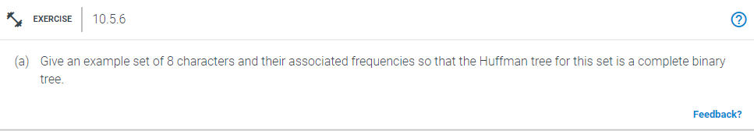

Answer:

In order to complete this problem you will have to complete two steps. First you must generate a Huffman Tree from the desired input characters. After you complete that step all you need to do is traverse the Huffman Tree and assign codes to each character. An example will be provided below:

| Char | A | B | C | D | E | F | G | H |
| --- | --- | --- | --- | --- | --- | --- | --- | --- |
| Freq | 2 | 2 | 3 | 3 | 2 | 2 | 3 | 3 |

Step 1: Make a minimum heap of 8 nodes, with each node serving as the single node at the root of a tree.

Step 2: Extract from the min heap two minimum frequency nodes. A new internal node with the right frequency should be added.

Step 3: Step 2 should be repeated until there is just one node left in the heap. which will result in the binary tree becoming complete.

Resulting Binary Tree below:



Step 4: You will now need to assign codes to characters as you navigate the new Huffman Tree. We give it 0 while moving to the left child. We give it one for being the right child. A visual representation of this step will be provided below:



Then you are complete. I will also provide the codes for all the characters below:

A = 000

B = 001

C = 100

D = 101

E = 010

F = 011

G = 110

H = 111

Problem 10.5.7

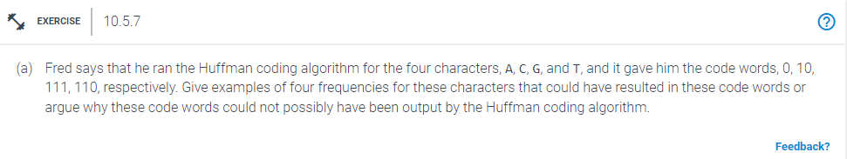

Answer:

If we give the characters the right frequency, we can really create the character codes that Fred provided using the information the problem provides.

Assume character frequencies:

A = 1

C = 2

G = 4

T = 5



This tree will provide the same results that Fred originally got.